Chip delayering by russian methods

<http://psxdev.ru>

## Overview

Method: manual lapping.

## Equipment

Needed equipment:

- simple cover glass

- glue «Moment»

- compatible Dremel

- hairy nozzle

- GOI paste

- house protection

Photos:

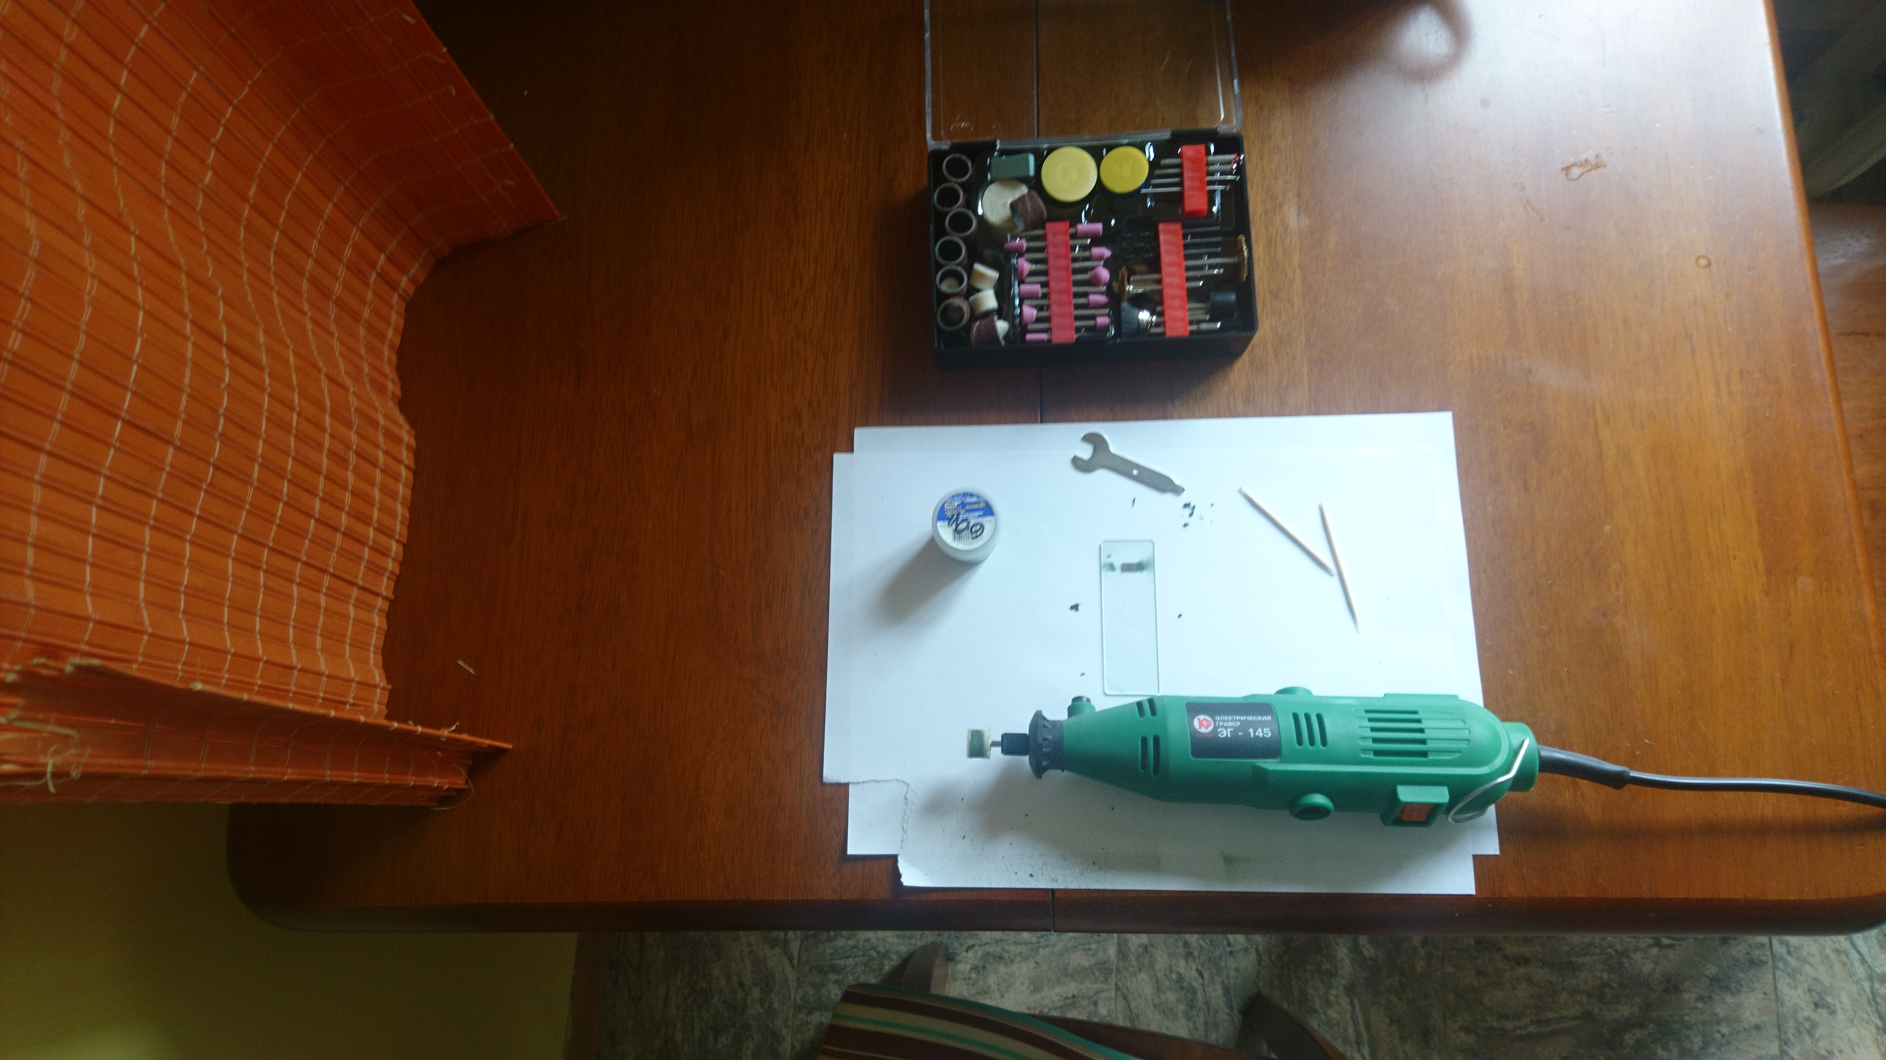

Picture 1- Kitchen Setup

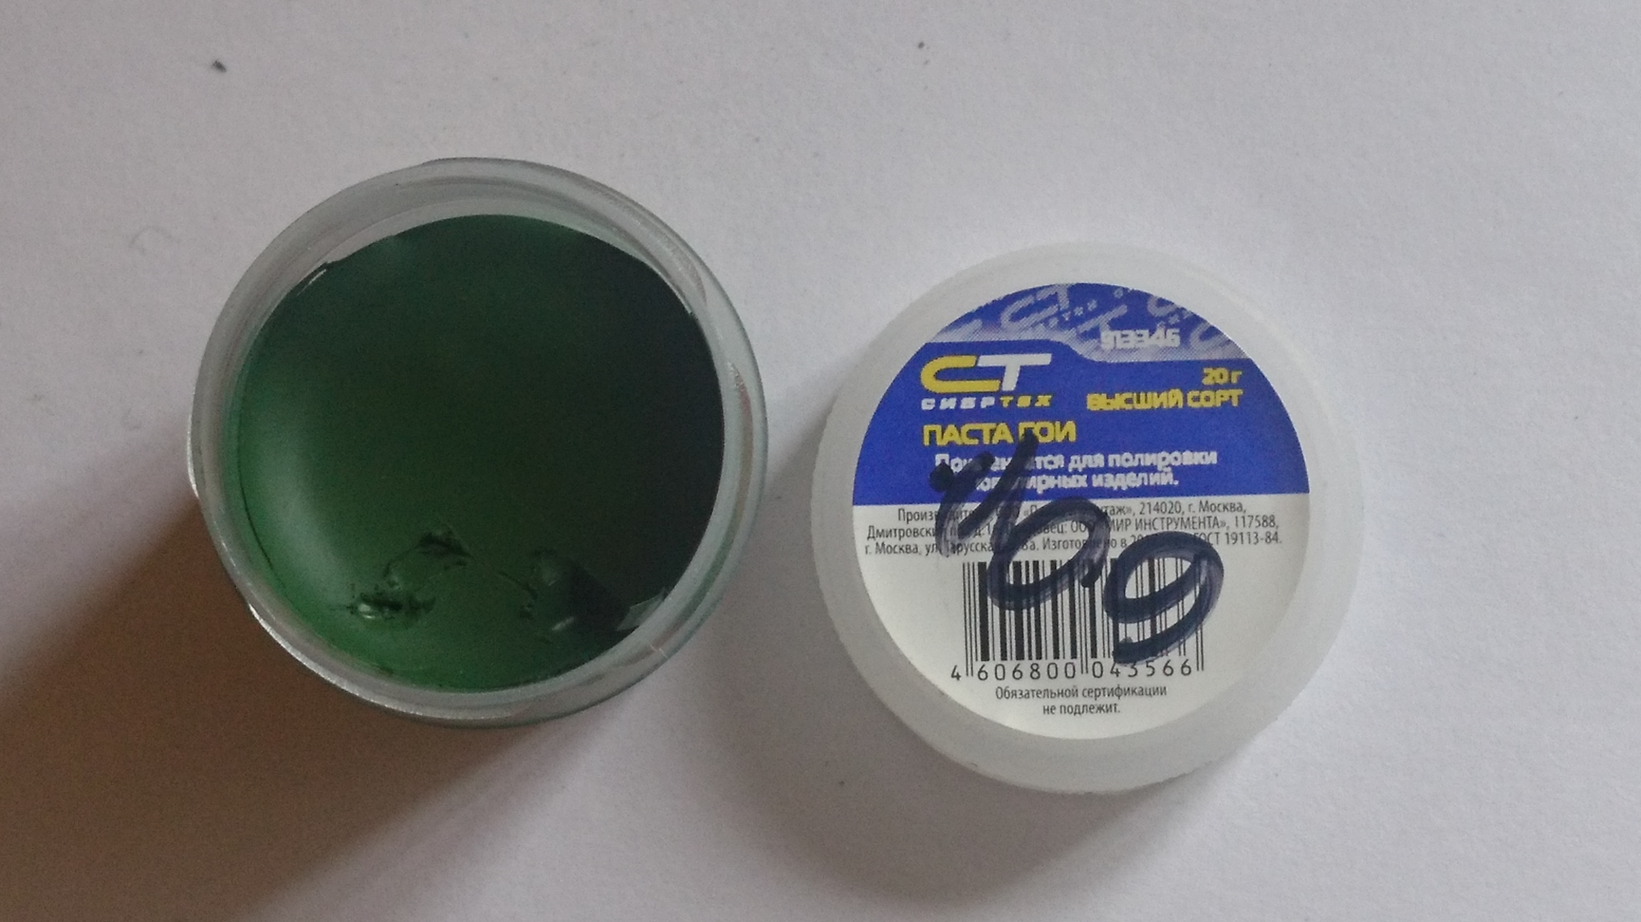

Picture 2 - GOI Paste

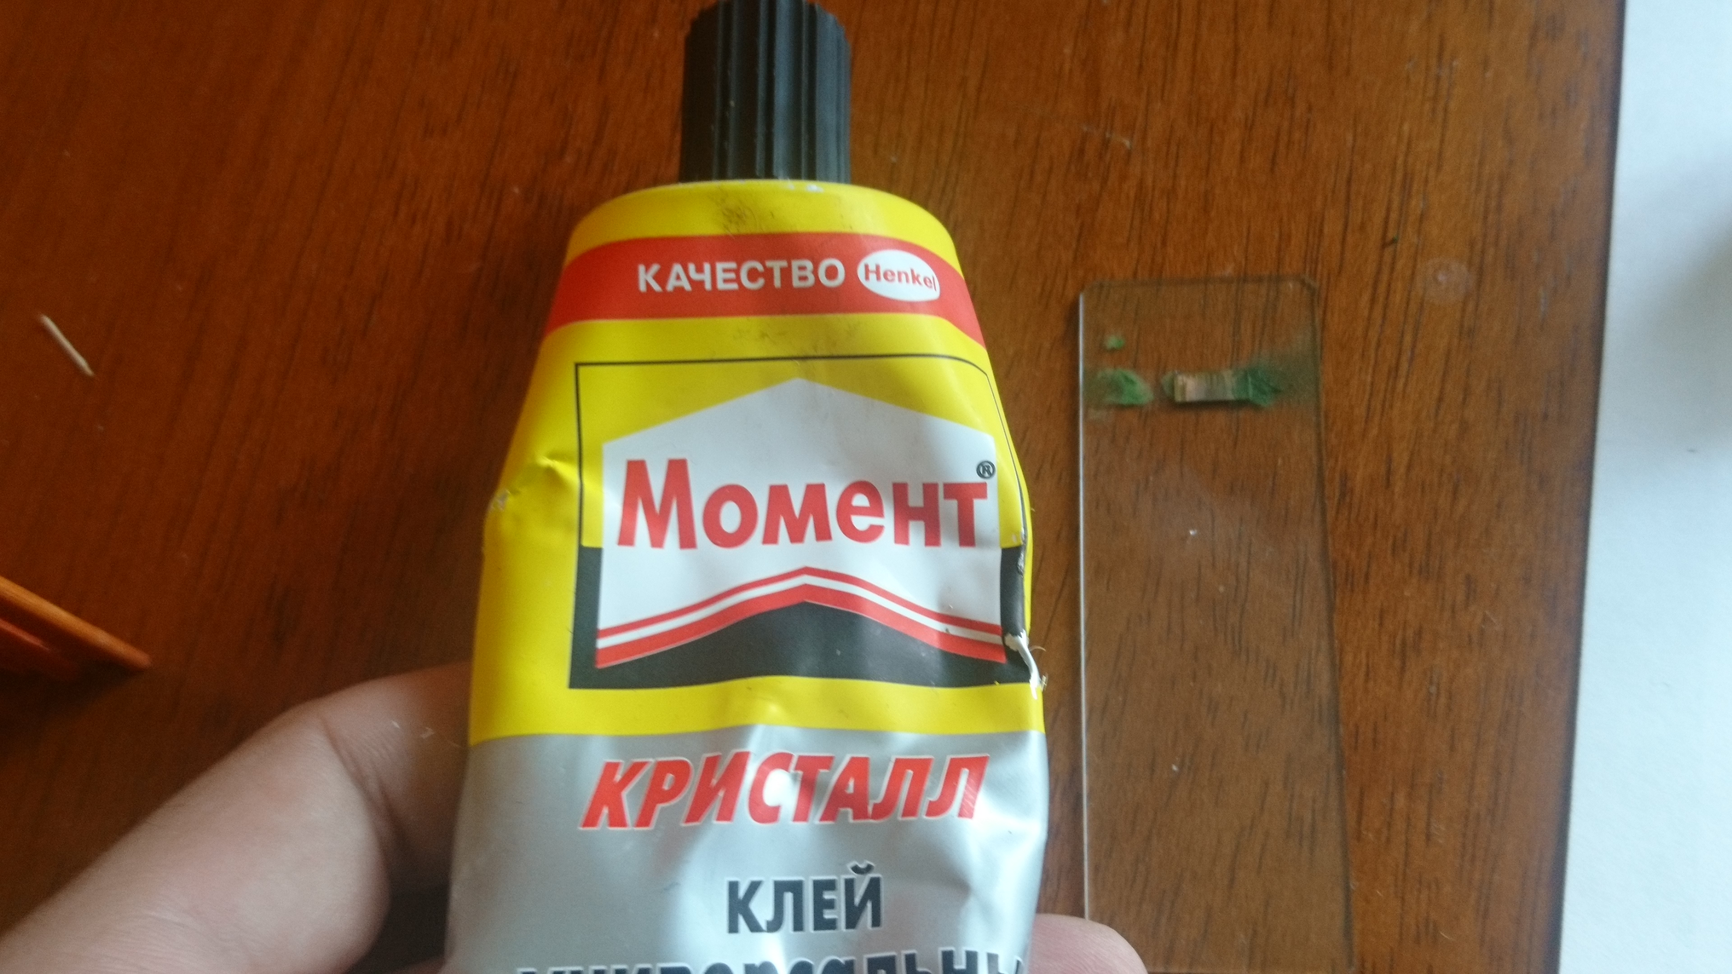

Picture 3 - Fix the chip on cover glash by glue

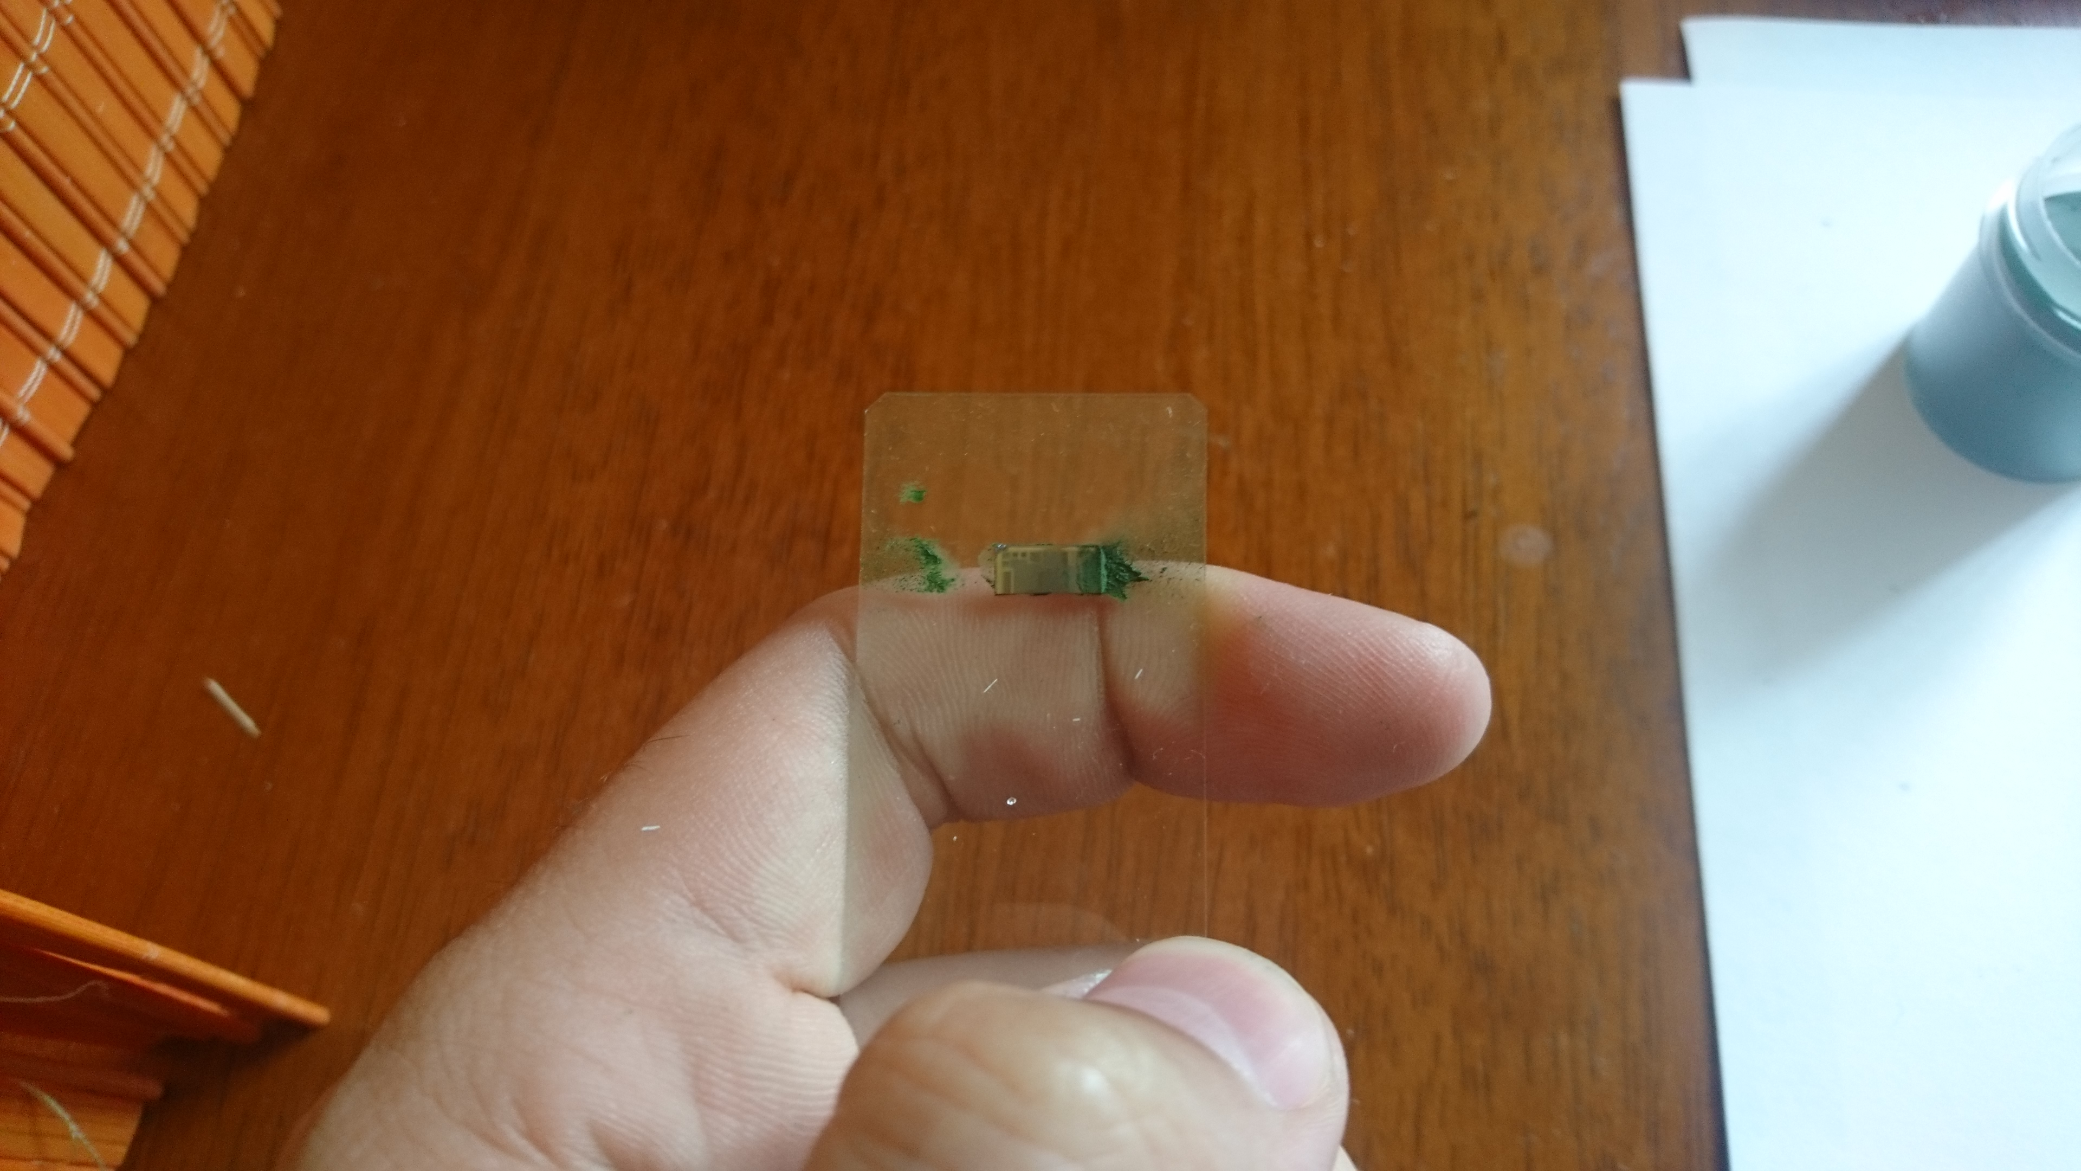

Picture 4 - Smear chip surface with a paste

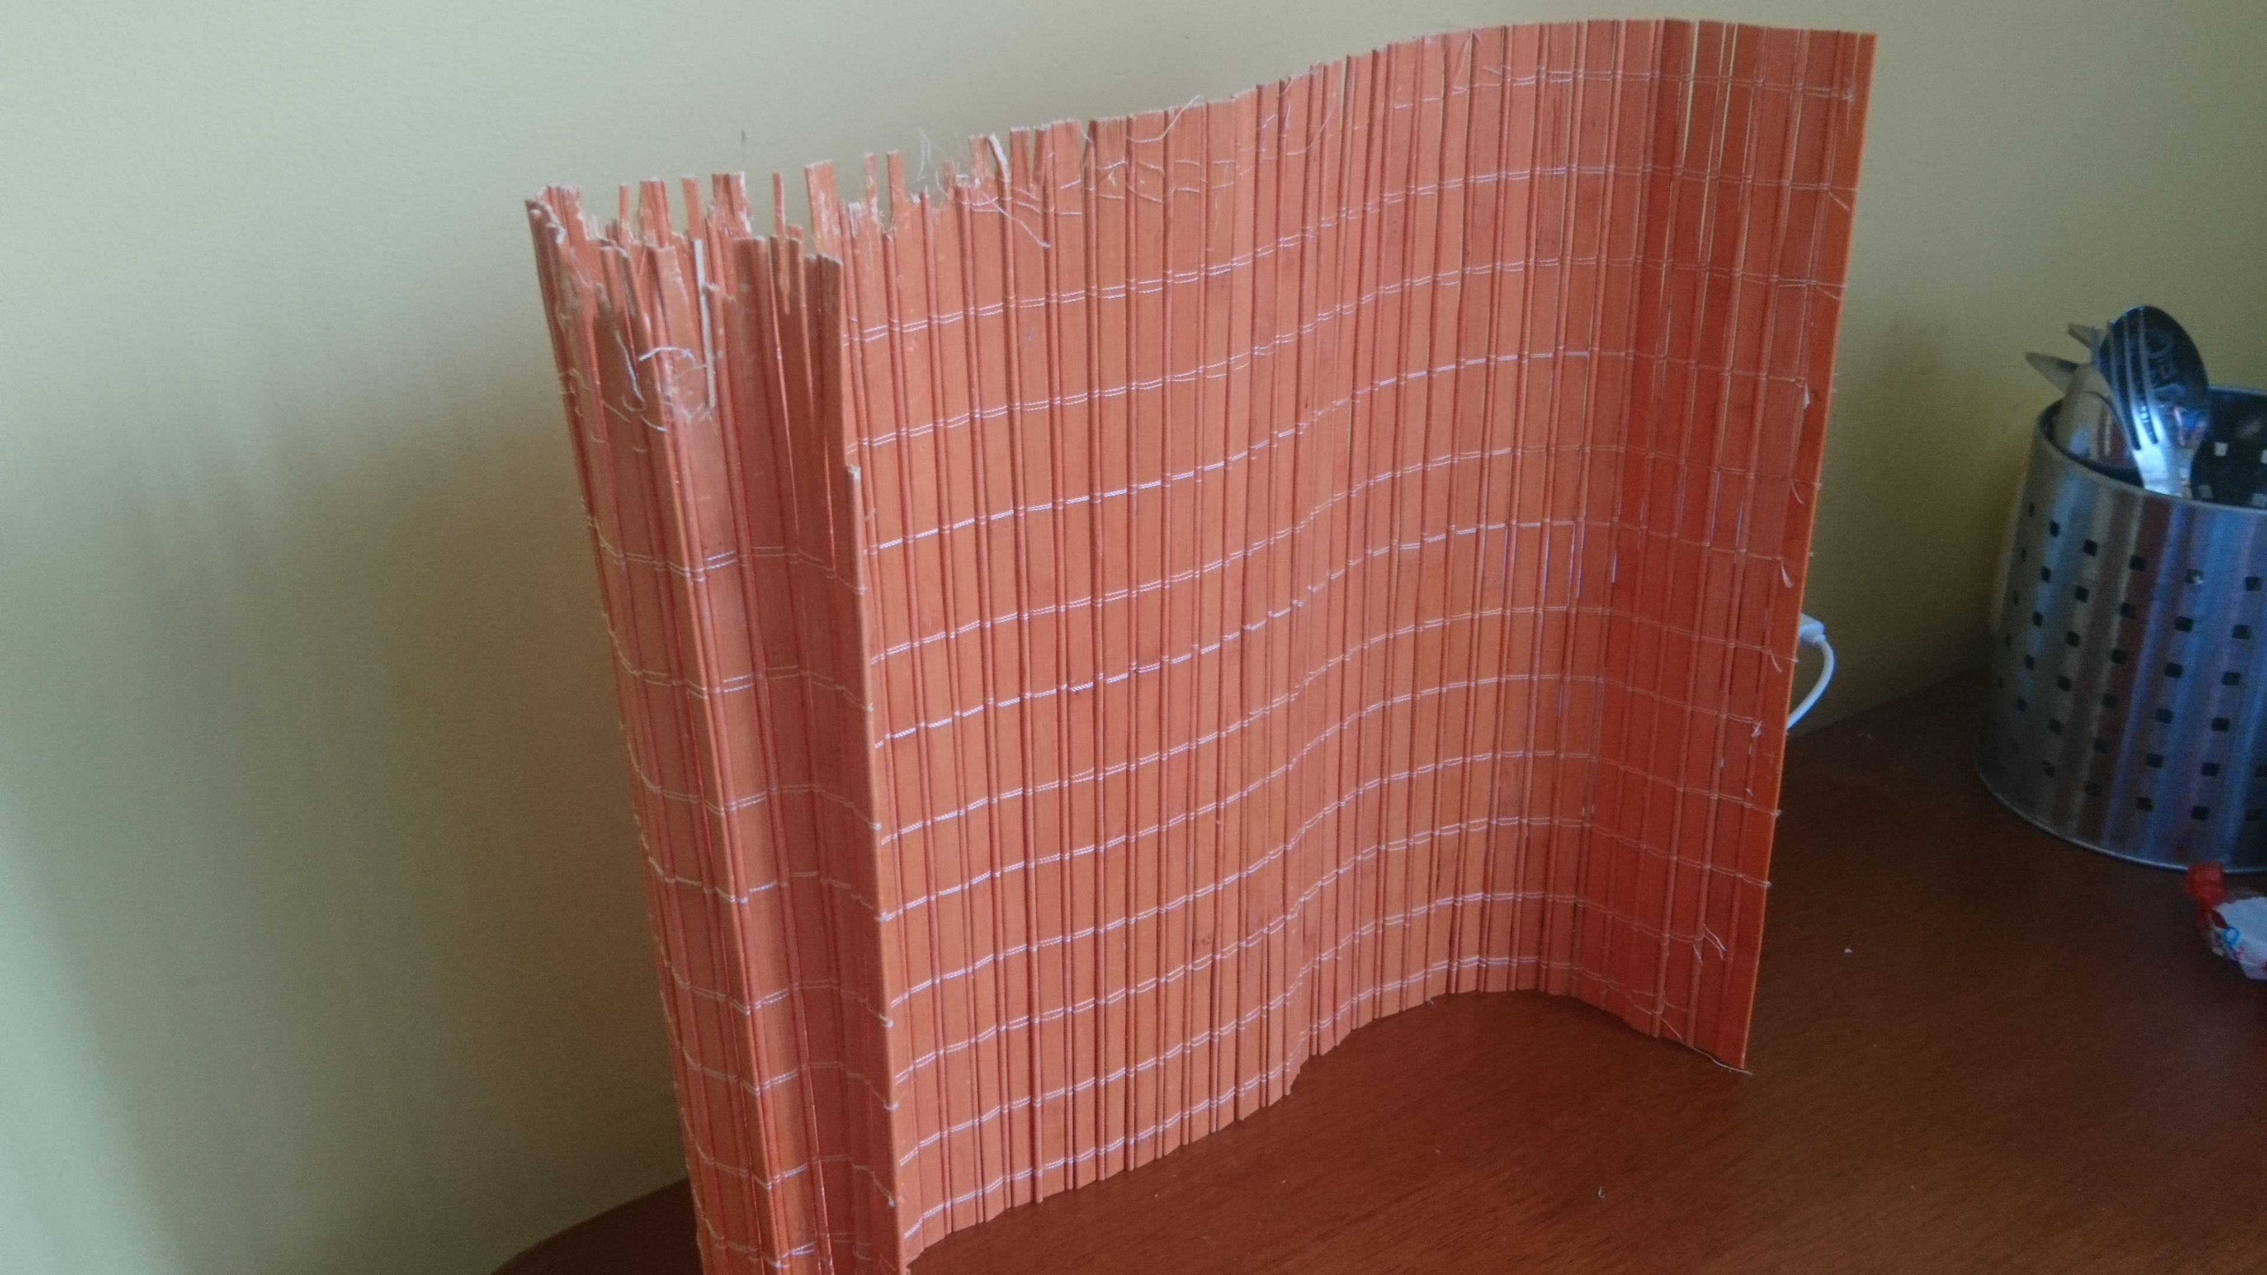

Picture 5 - Do not forget to protect the house from the shit flying around

## Processing

The speed of the dremel and the duration of the action are chosen experimentally.

At low speed, grinding is very slow or not at all. I set the average speed and worked on the surface for about 30 seconds. It was enough to remove the top layer of metal more or less evenly.

## Results

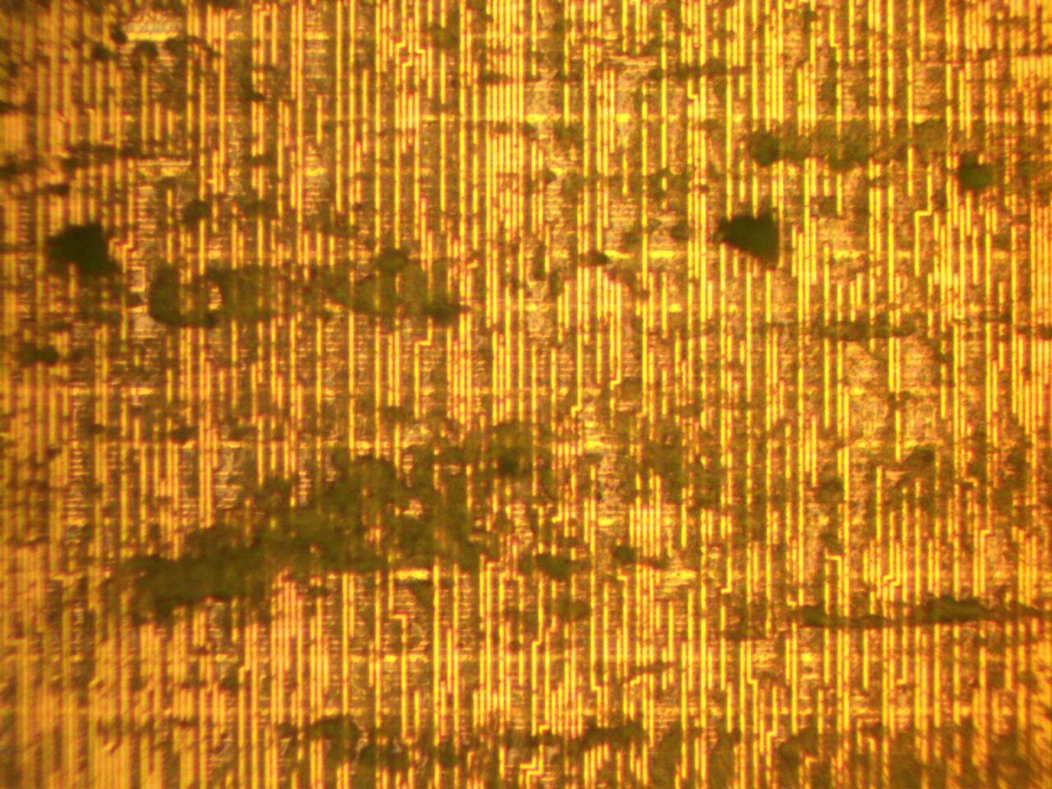

Picture 6 - The surface is evenly covered with shit

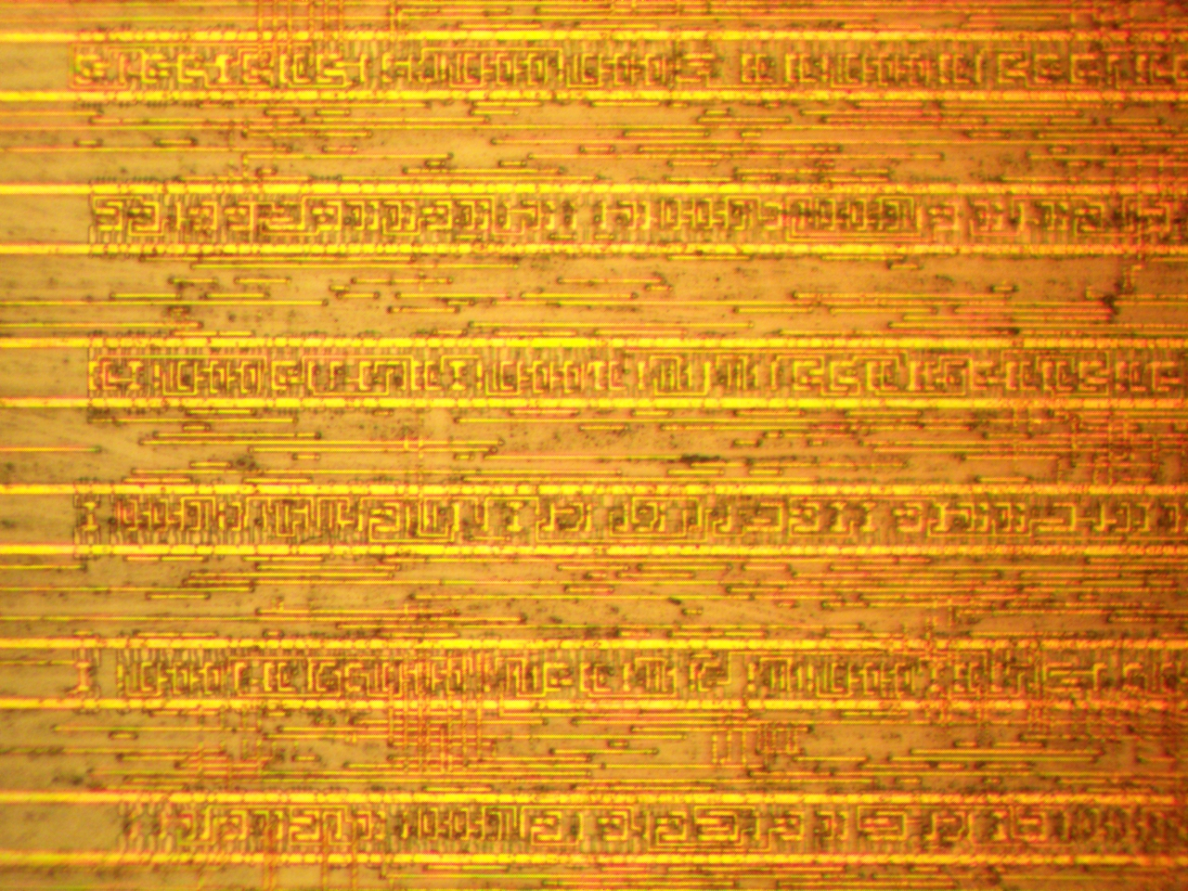

Picture 7 - Top metal layer lapped out